**VI. Industry Sector Specific Tools**

**Guidance for the Shipping Industry**

The resources below are intended for users from the shipping and freight forwarding industry. These resources can be used to develop and implement your enterprise’s ICP and to ensure that it addresses the unique issues and challenges facing brokers, shippers, freight forwarders, carriers, and customs agents.

**This section is organized as follows:**

* **Introduction**
* **Shippers Defined**
* **Licensing Requirements**
* **Enforcement Case Studies**
* **Reference Tools**
* **EXAMPLE: Transaction Screening Questions**

**To download the entire “Guidance for the Shipping Industry” section document,** **click here**

**Introduction**

The acquisition of WMD and their delivery systems is the prime focus of willful proliferators. In order to achieve their goal, they seek the path of least resistance - the unprotected border, the un-enforced regulation, or the lax STC licensing system. Likewise, non-compliance with the export/transit controls by enterprises adds to the proliferators' advantage. We must strengthen every link in the chain if we are to meet today's proliferation challenges.

Members of the international shipping community play a key role in ensuring the security of the global supply chain, stemming the flow of illegal exports, and helping to prevent WMD and other strategic goods and technologies from falling into the hands of proliferators and terrorists.

Shippers can take steps to mitigate their own and their clients' risks of liability by establishing a internal compliance program that scrutinizes export transactions. Like exporters, shippers should understand and be aware of licensing requirements, know their customers and inquire about the end-users, determine if diversion risk/red flag indicators are present, and ensure that suspicious circumstances are not overlooked or ignored. Such actions help protect not only the shipper but also the shipper's client who may be unknowingly engaging in a prohibited transaction.

The purpose of this section of the ICP Guide is to provide all members of the shipping community - **freight forwarders, carriers, and customs brokers** - with additional information to strengthen their compliance practices and behavior. Having developed general awareness of fundamental strategic trade control topics, and familiarity with key concepts and elements of a comprehensive and effective ICP, this section of the ICP Guide will equip shippers with additional knowledge and tools to help them tailor a compliance program that is uniquely suited to address their specific challenges, business model, and needs.

Gaining strategic trade control knowledge and implementing sound internal compliance practices will position shippers to:

* Mitigate their risks and stay compliant
* Provide value-added services to their clients
* Gain competitive advantages
* Help achieve private -sector and public-sector goals

Shippers and exporters are symbiotically situated to work together to develop compliance procedures for their mutual benefit and sustainability. Building compliance partnerships and sharing compliance strategies with each other and other parties to transactions as part of Standard Operating Procedures (SOPs) will give all involved a competitive edge. Once the investment is undertaken and the procedures are in place and continually maintained, export transactions will proceed predictably, safely, and with consistent application of the appropriate research and analysis of parties and uses/applications. As you share and learn compliance techniques with your business partners and build synergies while also building business relationships, you will ensure your mutual longevity and bottom lines.

**Shippers Defined**

There are several types of individuals and organizations involved in the movement of sensitive items. **Freight forwarders, carriers, port authorities, waterway operators, shipping companies, air carriers, railways, and trucking companies** form the bulk of this population.

While subsets within this population often interrelate, each performs different duties. Some of them are primarily responsible for moving actual cargo and others are responsible for maintaining ports, vessels, waterways, and other physical systems through which cargo passes.

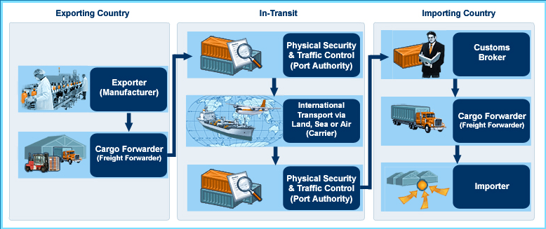The picture below provides a brief illustration of this relationship.

Shippers Defined: Shippers’ Roles

|  |  |  |
| --- | --- | --- |
| **Freight Forwarders** | **Carriers** | **Customs Brokers** |
| **Serve as agents who arrange for:**   * Shipment of goods belonging to their client/exporters * Packing Domestic and international transportation via sea, air or road * Payment of freight charges and insurance * Customs duties   **May consolidate goods at various points during transit**  **Are usually private enterprises**  **May be licensed by a government agency** | **May use their own methods of transportation**  **May partner with commercial carriers** | **Act on behalf of the importer to clear goods through customs and deliver items to the warehouse or final destination**  **Some freight forwarders are also customs brokers**  **Are usually licensed by a government agency** |

Shippers Defined: Responsibilities of an Exporter

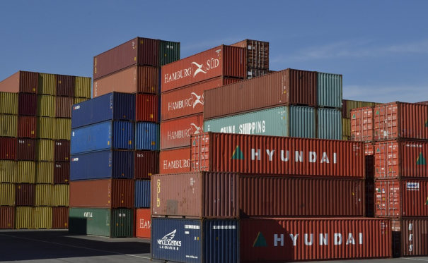

Many countries have adopted Internal Compliance Program (ICP) for exporters. An ICP is based on a corporate philosophy that says: "We want to maximize sales while also ensuring that we abide by all governmental regulations and laws and the strategic trade control standards of the international community."

Every enterprise that exports goods and services can establish an ICP to ensure that its actions do not violate the government's strategic trade control laws and regulations.

**Responsibilities of the exporter with regards to strategic trade controls are to:**

* Determine commodity classification of the item(s) to be shipped
* Determine whether the item requires an export license or if it can be exported under a license exception
* Conduct end-use/end-user screening
* Submit complete and accurate license application to the appropriate government authority
* Accurately complete the export documentation
* Maintain records as maintained by national legislation

Shippers Defined: Responsibilities of a Shipper

United Nations Security Council Resolution (UNSCR) 1540 states that in order to stem the proliferation of sensitive items, a country needs to establish, develop, review, and maintain appropriate effective national export/transit controls. In addition, the country has to establish and enforce appropriate **criminal or civil penalties for violations of strategic trade control laws** and regulations. Below are several examples of transit controls and penalties for acts of non-compliance.

**United States**

****The U.S. Export Administration Regulations (EAR) places legal responsibility on all persons who have information, authority, or functions relevant to carrying out export transactions subject to the EAR.

* Forwarding agents may have compliance responsibilities under the EAR even when their actions are dependent upon information or instruction given by those who use his/her services.
* Under the EAR, misrepresentations and false statements on export documents can result in penalties up to $125,000 to $250,000 per offense (depending on whether or not the violation is voluntarily disclosed).

**Japan**

****Japan’s *Foreign Exchange and Foreign Trade Act* stipulates specific penalties for strategic trade control violations, including the unauthorized transit of strategic items.

* Penalties violations involving WMD proliferation can include prison terms up to **10 years**
* Penalties for violations not related to WMD proliferation can result in prison terms of up to **7 years**

**Estonia**

* In Estonia, transit shipments must be licensed when the dual-use goods are carried though Estonia from a country outside of the EU to another country, or if **military-related goods** are carried through Estonia regardless of their final destination.
* Violations of these controls can result in **administrative and financial penalties**. Fines in Estonia range up to **3,205 Euros**.

**Hong Kong Special Administrative Region**

* The *Import and Export Ordinance,* Section 2 defines an ‘**article in transit**’ as an article which- (a) is brought in to Hong Kong solely for the purpose of taking it out of Hong Kong; and (b) remains at all times in or on the vessel or aircraft in or on which it is brought into Hong Kong”
* Section 6A: “An article in transit” [listed in Schedule 2*] requires a license issued by the Director. An offense “is liable on summary conviction to a fine of $500,000 and to imprisonment for 2 years; and on conviction on indictment to an **unlimited fine** and to **imprisonment for 7 years.”** Note: *A license is necessary for the transit of items found in Schedule 2. Schedule 2 is comprised of certain munitions, nuclear, and nuclear dual-use items; WMD-relevant items and related technical information.*

**Licensing Requirements**

While obtaining an export license for an item is the primary responsibility of the exporter, shippers also share the responsibility to ensure that the export is legal. Apart from the actual transport itself, shippers must be aware of the export/transit controls that apply to the transaction. This means that shippers must be knowledgeable of, and compliant with, licensing regulations and STC legal requirements.

Licensing Requirements: Defining Export/Transit Controls

Export/transit controls are essential for a country's national security, foreign policy, and economic interests. Effective controls involve using preventive and enforcement methods. These methods allow authorities to ensure their compliance and target violations without impeding the flow of legitimate business.

In this guide, references to "export/transit" include a number of circumstances under which goods leave one country destined for another. Export/transit controls are important for a country to prevent the export/transit of sensitive items, which are usually controlled by the government for concerns including:

* Military or WMD applications of the item;
* Destination country, organization, or individual; or
* Declared or suspected end-use or the end-user of the item.

**Export:** Shipment or transmission of items out of the country, to a foreign country.

**Re-Export:** Export of previously imported items.

**Transit:** Imported items en route to another foreign destination, but they stay onboard their means of conveyance. These items do not have a consignee in the country of transit.

**Transshipment:** Imported items that are temporarily unloaded in a country and then reloaded onto the same or another vessel, aircraft, or vehicle, and exported. Like transit items, these items do not have a consignee in the country of transshipment.

Licensing Requirements: Requirement for Export/Transit Controls

It is imperative that a country have both the legal authority and capability to deter, identify, and halt any transfer to end-uses or end-users of proliferation concern - even if the transfer is authorized by another state and only transiting your country.

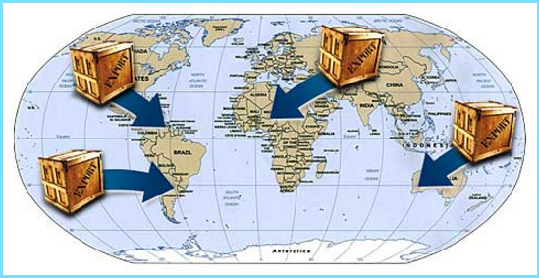

**Export/Transit controls are:**

* Mandated by the UN to prevent the proliferation of WMD
* Accepted international standards and best practices in the international trade community
* Most effective when they are harmonized

**Let us now look at the role of national and EU legislation, and UNSCR 1540 in export/transit controls in detail.**

Licensing Requirements: United Nations Security Council Resolution 1540

[United Nations Security Council Resolution (UNSCR) 1540](http://www.un.org/ga/search/view_doc.asp?symbol=S/RES/1540(2004)) was unanimously adopted in April 2004, in response to growing concerns of terrorism, illicit trafficking, and proliferation. UNSCR 1540 requires all UN members to:

* Adopt national legislation to control the manufacture, possession, and trafficking of WMD and their means of delivery
* Develop and maintain **effective national export, re-export, transshipment, and transit controls over such items,** including controls on providing funds and services regarding export and transshipment

Licensing Requirements: EU Regulatory Requirements

In the EU, shippers have compliance responsibilities under the EU Regulations even when their actions are dependent upon information or instructions given by those who use their services. Chapter I, Article 2 of the ***COUNCIL REGULATION (EC) No 428/2009 of 5 May 2009***setting up a Community regime for the control of exports, transfer, brokering and transit of dual-use provides the following definition of

"**Exporter**," to include shippers: ... "exporter" shall mean any natural or legal person or partnership:

* On whose behalf an export declaration is made, that is to say t**he person who, at the time when the declaration is accepted, holds the contract with the consignee in the third country and has the power for determining the sending of the item out of the customs territory** of the Community. If no export contract has been concluded or if the holder of the contract does not act on its own behalf, **the exporter shall mean the person who has the power for determining the sending of the item out of the customs territory** of the Community;
* Where the benefit of a right to dispose of the dual-use item belongs to a person established outside the Community pursuant to the contract on which the export is based, **the exporter shall be considered to be the contracting party** established in the Community;

Shippers are responsible for the representations they make in filing export data. No person, including an agent, may proceed with any transaction knowing that a violation of the EU Regulations has, is about to, or is intended to occur. **It is the agent's responsibility to understand its obligations.** **Shippers may also be subject to criminal prosecution and/or administrative penalties for violations of the EU Regulations**.

**[Insert the name of your country**]

[Insert national definitions of “exporter” and “export” and any other relevant legal provisions that may apply to shippers. Refer to relevant legislation and legal provisions]

Licensing Requirements: Export or Commodity Classification Number (ECN or CCN)[1]

A CCN or ECN describes a particular item or type of item in technical detail, shows the controls placed on that item, and should appear on export documentation including the export license and accompanying shipping documents. The CCN/ECN is denoted, with the description of the item, on a country’s national control list (NCL).

**The example below (Gravity meters and gravity gradiometers) provides insight into the structure of CCNs:**

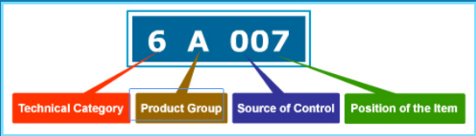

**6** The first character (number) - represents the overall technical category of the item. This character is a digit in the 0 - 9 range.

**A** The second character (letter) represents the product group. This character is a letter ranging A - E.

**0**The third character (number) - indicates the Multilateral Export Control Regime (MECR) from which the item is derived.

**07**The fourth and fifth characters (numbers) - represent the position of the item within the technical category and the product group.

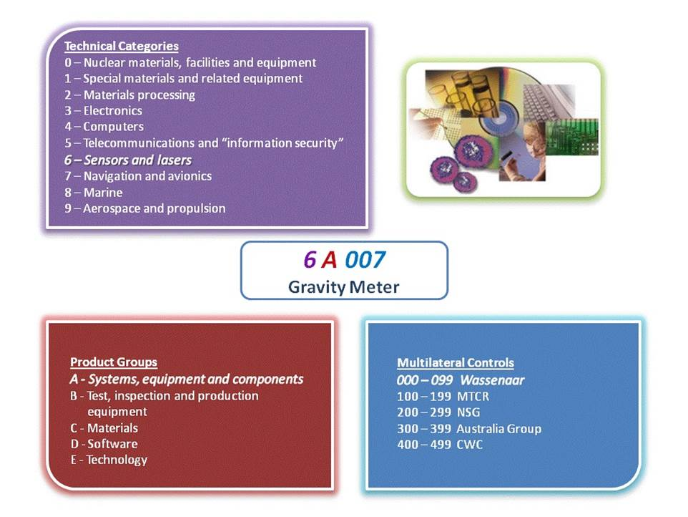

Licensing Requirements: Harmonized System (HS)

National Control Lists (NCLs) are used in a country's export control process. For the import control process, the Harmonized System (HS) is used. The HS is an international method of classifying products for tariff and statistical purposes. It is widely used by Customs officials to determine duties, taxes, and regulations that apply to imports. Under the HS, imports are assigned a six-digit identifying number.

**The example below provides insight into the structure of Harmonized System (HS) codes:**

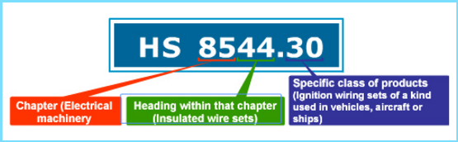

**85** The first two digits of this number identify the chapter into which the product falls.

**44**The second two digits identify the heading within that chapter.

**30**The final two digits identify a specific class of products.

Licensing Requirements: Comparing NCL and HS Entries

A commodity control number (CCN) might describe items that are covered in several HS entries. Similarly, an HS code can cover items described by more than one CCN. However, almost never will the entire coverage of an HS number and the entire coverage of a CCN be identical. HS codes are usually broad and inclusive of multiple commodities, while CCNs tend to be more precise, with technical characteristics and descriptions that are specific to a singular commodity.

**NCL Entries**

* Used to determine whether a particular item requires an export license
* Technology, services, and technical data are classified in the NCL (dual-use or military)
* Covers items (goods, technology, and services) that require export controls

**HS Entries**

* Used for classifying products for tariff and statistical purposes
* Classifies all physical products
* Does not cover technology

Note: *Shippers or agents should avoid making commodity classifications for which they lack technical expertise, and if in doubt should obtain support documentation for the Commodity / Export Classification Number (ECN or CCN).*

If the correlation shows a match between your HS number and a CCN, it is only a possibility, but not a certainty that the item is controlled. In that case you need to carefully read the specified CCN and then determine whether it describes your item or not. The following entry (**Magnetic powder**) illustrates one control number covering items in more than one HS code:

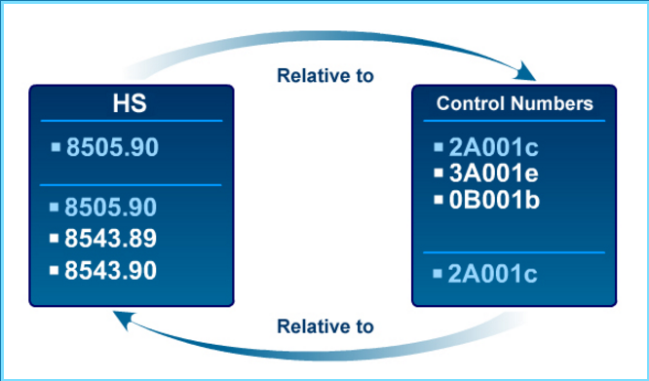

Licensing Requirements: End-User/Foreign Consignee

While obtaining an export license for an item is the primary responsibility of the exporter, shippers are also responsible to ensure that the exports comply with national laws and regulations. Shippers must ensure that they do not export items to prohibited foreign consignees by being knowledgeable about published lists of prohibited end-users and sanctioned groups.



Shippers must also scrutinize packages to ensure that they comply with national laws and be aware of 'red flag' indicators of suspicious activity. If red flags are present, shippers should exercise due diligence in inquiring about the facts of the transaction and ensure that suspicious circumstances are not ignored.

If the red flags cannot be resolved, shippers should refrain from engaging in the transaction. These steps help protect not only the shippers but also the shippers' client, who may be unknowingly engaging in a prohibited transaction.

Licensing Requirements: Exporter vs. Freight Forwarder Responsibilities

***Product classification***

* + Exporters should **classify each product** in accordance with the requirements of the strategic trade control regulations in the country in which they operate. Note: *If the finished product contains controlled U.S.-origin technology, the transaction may also be subject to* ***U.S. extra-territorial re-export controls****.*
  + Exporters should **communicate the appropriate commodity or export classification number** (CCN/ECN) or other classification information for each export **to the trade facilitator or freight forwarder and the end-user** involved in that export.
  + The freight forwarders and logistics enterprises must assure that the information they input in the export related **documents** is **current and accurate**.
  + All (exporting, freight forwarding, and logistics) enterprises involved in the transaction should also **maintain a record of each classification** for every export.

***End-Use and Party Screening***

* All enterprises should **screen all parties to the transaction against all restricted parties lists required under your country’s STC rules** (Examples: national/unilateral restricted party list, UN Consolidated Sanctions List, Japan Foreign End-User of Concern list, or the EU Consolidated List) and maintain records of all screenings.
* All enterprises should **screen all exports/re-exports against a list of embargoed/sanctioned destinations** and maintain records of all such screenings.

***Transit/transshipment hub***

* Enterprises should pay special attention with respect to, from, or through **transit or transshipment hubs** as they may provide opportunity to conceal the true end-user
* All enterprises should have in place compliance and or business procedures to be immediately **responsive to theft or diversion**. This includes procedures such as document confirmation to ensure that the exported item has reached the appropriate end-user.
* All enterprises should pay heightened attention to “**red flag” indicators** and other **indicators of diversion or proliferation risk**.

***Responding to suspicious transactions***

* When any company encounters a suspicious transaction, it should **hold the shipment** and consult with this empowered compliance official.
* If the transaction is determined to involve potential or actual violation of applicable STC regulations, the enterprise should **contact the appropriate government agency** immediately and retain all relevant records.

Licensing Requirements: Non-listed Items and Catch-all Controls

Now that you have a good idea about the NCL and the responsibility for product classification and suspicious transactions, let us focus on the items which are of proliferation concern but are not found on any of the multilateral export control regime (MECR) lists.

A large percentage of the goods and technology required for a project or facility of concern involving WMD or missile delivery systems are not found on the MECR lists. The question is how to curb items which do not appear on any list. This is where **“catch-all” controls** come into play.

Catch-all controls are **based on the end-use or end-user of the item**. These controls create the means of imposing **license requirements on non-listed items**, and are designed to help further prevent the proliferation of WMD and their delivery systems.

Catch-all controls are based on the concept that an export license should be required for any item, regardless of its level of sophistication, which is going to an entity involved in WMD-related activities. Even low-level items (such as test tubes) that are not on any control list might require a license if they are going to an entity or end-use of proliferation concern.

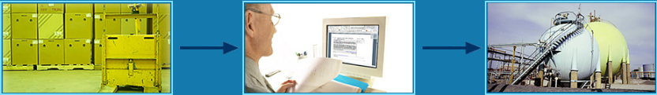

**Item to be exported**

**Filter**

**Chemical plant for making CWs (restricted end-use)**

Note: *Unlike controls imposed pursuant to the NCL, which are based on technical parameters, catch-all controls are based on the potential end-use or end-user of the item and the potential for the item to contribute to a WMD or military program or another unauthorized end-use.*

Catch-all controls supplement the lists of items of the multilateral export control regimes - the Nuclear Suppliers Group (NSG), the Missile Technology Control Regime (MTCR), the Australia Group (AG), and the Wassenaar Arrangement (WA). To be most effective, catch-all controls need to be applied multilaterally, consistent with each country's legal system.

The **European Union has established dual-use transit controls** based on catch-all provisions. COUNCIL REGULATION (EC) No 428/2009 of 5 May 2009setting up a Community regime for the control of exports, transfer, brokering and transit of dual-use items stipulates the following: "The transit of listed dual-use items may be prohibited by the competent authorities of the Member State where the transit occurs if the items are or may be intended, in their entirety or in part, for use in connection with the development, production, handling, operation, maintenance, storage, detection, identification or dissemination of chemical, biological or nuclear weapons or other nuclear explosive devices or the development, production, maintenance or storage of missiles capable of delivering such weapons."

In the **U.S.** export control regulations, an 'Entity List' is published for exporters. Any goods destined for a party who is listed on the Entity List will require an export license under the end-use/end-user control requirement. Additionally, an end-use/end-user licensing requirement exists for end-users not found on the Entity List, but who are known, or suspected, to be involved in WMD-related activities.

Note: *The* [***Restricted Party Screening Tool (RPST)***](http://rpst.rit.albany.edu/)*that is part of this guide will enable your enterprise to screen all parties to a transaction against the EU Consolidated List, U.S. Consolidated List, and the Japan Foreign End-User List. The RPST can also be modified to screen against any unique, unilateral/national list that may be maintained in your country.*

**[Insert name of your country]**

**[**Insert name of your country**]** has established dual-use transit controls [based on catch-all provisions?] set forth by [insert name of relevant STC legislation and relevant article/section]:

“Transit” is defined as: [insert definition of transit as it relates to dual-use items]

License Requirements: Red Flags

Recall that many items of proliferation concern are not found on any multilaterally-defined lists or national control lists. Also, proliferators often **elude detection by using a benign entity name or** **understating the technical capabilities of the item**. Shippers should be alert to any indicators that the exporter intends to export goods to a suspicious end-user or for a suspicious end-use. Such indicators are referred to as 'red flags'.

A red flag is **a warning signal or indicator that there maybe an illegal activity in process, or that items may be en route to a suspicious end-user**. In export/transit control terms, this translates to looking for things that do not seem logical or are falsely described.

**Some examples of red flags include:**

* A shipper in the chain is not a known or established enterprise
* Products are not compatible with the customer's business
* Listed value is in excess of the fair market value
* Final consignee is a freight forwarder
* Delivery dates are vague or ambiguous
* The shipping route is circuitous and illogical

License Requirements: Know Your Customer

Take into account any abnormal circumstances in a transaction that may indicate that the export may be destined for an inappropriate/restricted end-use, end-user, or destination.

**RED FLAGS -** When red flags are raised in the information that comes to your firm, you have a duty to investigate the suspicious circumstances, and inquire about the end-use, end-user, or country of destination.

**YES**

**NO**

**NO RED FLAGS -** There is no affirmative duty upon shippers to inquire, verify, or otherwise "go behind" the customer's representations.

[**Red Flag Actions**](http://icp.rit.albany.edu/index.php/the-elements-of-an-internal-compliance-program/transaction-screening-process-and-procedures?limitstart=0)

 **Do not self-blind** Do not cut off the flow of information that comes to your firm in the normal course of business. A company is not insulated from liability by taking steps to avoid "bad" information, and it would usually be considered an aggravating factor in an enforcement proceeding. Employees need to know how to handle red flags.

**Knowledge possessed by an employee** of an enterprise can be imputed to a firm so as to make it liable for a violation. This makes it important for firms to establish clear policies and effective compliance procedures to ensure that such knowledge about transactions can be evaluated by responsible senior compliance officials. Failure to do so could be regarded as a form of self-blinding.

**Reevaluate all the information after the order inquiry** - The purpose of this inquiry and reevaluation is to determine whether the red flags can be explained or justified. If they can, you may proceed with the transaction. **If all doubts are not resolved, refrain from the transaction, disclose the information to your firm’s CCO or the government authorities** and wait.”

Note: *The Implementation Aids section of the ICP Guide contains red flag checklists, diversion risk checklists, and other practical screening resources that may assist your enterprise. Please* [***click here***](http://icp.rit.albany.edu/index.php/implementation-resources/icp-implementation-aids?start=3) *to access these materials.*

Licensing Requirements: Additional Precautions

In addition to red flags, shippers should also be aware of the **package handling instructions**. Sometimes the **signage on the package can warrant further investigation**. Often, the products in such packages will be on the control list, and will require an export or transit license.

**Some examples of the categories that merit attention by the shippers include:**

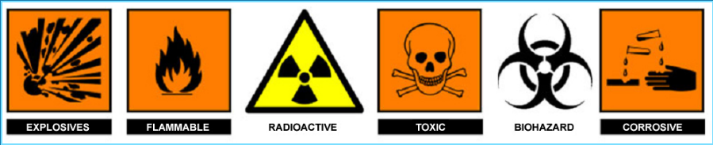

Licensing Requirements: Assessing Transaction Risks

**The graphic below provides a “risk matrix” based on various indicators. A risk matrix can be useful tool to assist your enterprise in determining the level of risk associated with a transaction.**

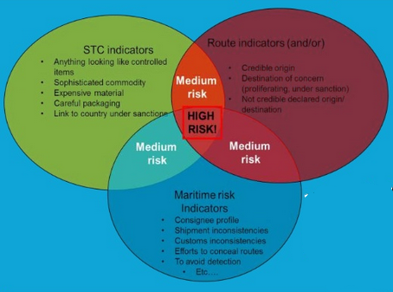

Note: *The Implementation Aids section of the ICP Guide contains a risk matrix and a diversion risk checklist, and other practical resources that may assist your enterprise in screening transactions. Please* [***click here***](http://icp.rit.albany.edu/index.php/implementation-resources/icp-implementation-aids?start=3) *to access these materials.*

**Enforcement Case Studies**

**Criminal and Administrative Case Examples**

* *Misrepresentation and false statements on shipping documents*

1. **Go Trans (North America)/Roger Unterberger/Muhammad Bhatti**

The Violation: Go-Trans (North America), of Jamaica, New York, a freight forwarder, Roger Unterberger, a retired Senior Vice President of Gondrand AG, headquartered in Basel, Switzerland, and Muhammad Bhatti, Chief Operating Officer of Go-Trans, made false statements in connection with the attempted export of pipe cutting machines to Iran via Germany.

The Penalty: All three pled guilty to false statement charges. On October 24, 2007, Go Trans was sentenced to one year of probation and a $34,000 criminal fine; Roger Unterberger was sentenced to one year of probation and a $5,000 criminal fine; and Muhammad Batti was sentenced to one year of probation. In the related administrative cases, Bhatti paid a $34,000 penalty, Unterberger paid a $25,500 penalty, and Go Trans paid a $34,000 penalty.

1. **Fulfill Your Packages (FYP)**

The Violation: Fulfill Your Packages (FYP) of Gresham, Oregon, allowed its foreign customers in China to use its U.S. domestic address for the purchase and delivery of items from U.S. companies that FYP later repackaged and/or relabeled for export to China. In about June 2014, FYP engaged in a transaction or took other actions with intent to evade U.S. export control regulations in connection with the intended export of a FLIR thermal imaging camera classified as U.S. ECCN 6A003 and controlled for national security and regional stability reasons. Specifically, a FYP customer purchased the camera from a U.S. distributor located in Florida for delivery to FYP’s offices in Oregon and for ultimate export to China. The FYP customer provided FYP’s address as his own and did not disclose to the U.S. distributor that the thermal imaging camera was to be exported to China. The shipment from the distributor to FYP included an invoice that warned that the product was export-controlled and that was a violation of U.S. law to export the product to certain countries without the required export license. In addition, a label affixed to the item noted that the item was subject to U.S. Department of Commerce export control regulations and must not be exported outside the U.S. or Canada without a U.S. export license. In preparing to export the thermal imaging camera to China, FYP prepared a shipping label falsely describing the item as “metal parts” valued at $255, even though FYP’s order system described the items as an infrared webcam/surveillance camera installation kit, and even though the distributor’s invoice described the items as a thermal imaging camera valued at $2,617.

The Penalty: On June 17, 2016, FYP agreed to pay a $250,000 civil penalty with $190,000 suspended provided no violations occur during a two-year probationary period.

1. **Elite International Transportation, Inc.**

The Violation: Between 2000 and 2004, Elite International Transportation, Inc. ("Elite"), a freight forwarder in Houston, Texas, misrepresented the licensing authority on Shipper's Export Declarations (SEDs). Elite filed SEDs on behalf of an exporter, Equistar Chemicals LP ("Equistar"), of Houston, Texas, stating that exports of the chemical Triethanolomine to Mexico were authorized pursuant to NLR ("No License Required"), when, in fact, a license was required for the exports.

The Penalty: Elite agreed to pay a $156,000 civil penalty. In a related matter, Equistar agreed to a civil penalty of $39,650. Equistar had filed a Voluntary Self-Disclosure (VSD) with BIS in 2004.

1. **UTI**

The Violation: On one occasion in November 1, 2000, in connection with effecting an export subject to the Regulations, UTI, a freight forwarder, made a false statement to the U.S. Government. UTI filed or caused to be filed a Shipper's Export Declaration (SED) for the export of computer parts and accessories, items subject to the Regulations that omitted the exporter's Employer Identification Number (EIN). In so doing, UTI committed one export violation. On 33 occasions between April 29, 2001, and June 11, 2004, in connection with effecting the export of a range of items subject to the Regulations, UTI made false statements to the U.S. Government. UTI filed or caused to be filed SEDs for the export of the items that included false information about the exporter's EIN. In so doing, UTI committed 33 export violations.

The Penalty: A civil penalty of $76,500 is assessed against UTI.

1. **Air Cargo International (ACI)**

The Violation: In June 2004, Air Cargo International (ACI) was accused of aiding and abetting the attempted unlicensed export of two thermal imaging cameras from the U.S. to an entity in the United Arab Emirates (the "UAE") by completing a Shipper's Export Declaration (SED) for the cameras that contained false statements of fact, and by signing the U.S. exporter's name on the signature line of the SED without receiving the necessary information from the exporter. Specifically, ACI filed an SED that stated that the thermal imaging cameras qualified for export under NLR (No License Required). This representation was false, as the thermal imaging cameras, classified under ECCN 6A003.b.4, required licenses for export to the UAE. Specifically, ACI was charged with filing or causing to be filed an SED that stated that the thermal imaging cameras qualified for export without a license. This representation was false, as the thermal imaging cameras required a license for export to the UAE.

The Penalty: A civil penalty of $11,000 was assessed against ACI.

1. **R&A International Trading Inc. dba R&A International Logistics (“R&A International”)**

The Violation: From in or about October 2009, through at least May 2012, Jamaica, New York-based freight forwarding company R&A International Trading Inc. dba R&A International Logistics (“R&A International”), and its president and owner Rukhsana Kadri aka Roxanne Kadri (“Kadri”), of Davie, Florida, conspired to conceal and misrepresent the identity of the exporter or U.S. Principal Party in Interest (“USPPI”) on Shipper’s Export Declarations or Automated Export System records (“SED/AES records”) filed with the U.S. Government, and committed a series of related violations, including soliciting a false statement during the course of an investigation. R&A International and Kadri conspired with one of their customers, the actual exporter/USPPI (“Customer No. 1”), to falsely list another of their customers (“Customer No. 2”) as the USPPI in SED/AES filings they made in connection with at least 278 exports of computer equipment, involving items totaling approximately $22 million in value, primarily to trading companies in the United Arab Emirates. The scheme enabled Customer No. 1 to repeatedly export the items anonymously and contrary to the terms of a distribution agreement, and enabled R&A International and Kadri to obtain Company No. 1’s substantial forwarding business. When OEE Special Agents began investigating the transactions, R&A International and Kadri not only made a series of false statements to the Special Agents in an attempt to cover up the conspiracy, but also attempted to enlist Customer No. 2 in the conspiracy and solicited Customer No. 2 to make false statements to the Special Agents to conceal the scheme. Customer No. 2, whose name had been falsely listed in the SED/AES filings without its knowledge or consent, refused.

The Penalty: In December 2013, R&A International and Kadri entered into plea agreements with the U.S. Attorney’s Office for the Eastern District of New York, admitting to knowingly making false statements in violation of 13 U.S.C. § 305, in connection with a subset of 10 of the false SED/AES record filings that the New York Field Office had identified, and agreed to forfeit $125,263. In addition to the forfeiture, R&A International was sentenced in August 2014 to two years’ probation, a criminal fine of $100,000, and a $4,000 special assessment, and Kadri was sentenced to three years’ probation, a criminal fine of $30,000, and a $100 special assessment. In July 15, 2016, during the first day of an administrative trial before an administrative law judge, R&A International and Rukhsana Kadri jointly and severally agreed to pay a civil penalty of $500,000, of which $350,000 is suspended during a five-year probationary period, and agreed to a five-year suspended denial order. In entering into and as part of the settlement agreement, R&A International and Kadri admitted each of the allegations and violations charged by BIS.

1. **Biospherical Instruments, Inc./ Baltrans Logistics, Inc.**

The Violation: In 2004, Biospherical Instruments, Inc. of San Diego, CA, exported a profiling radiometer system to the Space Application Center in India, an organization on BIS's Entity List, without the required license, and made a false representation to the U.S. government in connection with the preparation and submission of an export control document. Baltrans Logistics, Inc., of Torrance, CA, aided/abetted the unlicensed export.

The Penalty: On April 20, 2007, Biospherical Instruments, Inc. agreed to pay a $13,200 civil penalty. On the same day, Baltrans Logistics, Inc. agreed to pay a $6,000 civil penalty.

Mitigating Circumstance: Biospherical Instruments, Inc. voluntarily self-disclosed the violation and cooperated fully with the investigation.

* *Shipping without a license*

1. **General Logistics International**

The Violation: On four occasions between during November 2009, General Logistics International of New Brunswick, New Jersey, facilitated the unauthorized export of EAR99 steel scrap, valued at $672,022, from the U.S. to the People’s Steel Mills, located in Pakistan. The People’s Steel Mill appears on BIS’s Entity List. For each export, General Logistics International arranged for the trucking of the scrap steel from the U.S. exporter’s location to the port of export, arranged for the shipping of the scrap steel to People’s Steel Mills in Pakistan, and prepared and submitted shipping documentation, part of which indicated that no license was required for these exports.

The Penalty: On January 22, 2015, General Logistics International entered into a settlement agreement with BIS in which it agreed to pay $90,000.

1. **Naji Antoine Abi Khalil and Tomer Grinberg**

The Violation**:** NAJI ANTOINE ABI KHALIL ("Khalil"), holding a dual citizenship in both Lebanon and Canada, and Chairman and General Manager of New Line Services, an import/export shipping company in Montreal and TOMER GRINBERG ("Grinberg"), an Israeli citizen employed at the Tober Group, a shipping and logistics company based in Brooklyn, New York, were involved in a scheme to ship Generation 3 night vision equipment, including night vision goggles and infrared aiming devices to Greece without the licenses required by State and BIS. The infrared aiming devices were designed to be mounted on M-16 and other military rifles for target acquisition purposes when using night-vision goggles. Generation 3 is the highest level of night-vision technology and cannot be exported without a license. Khalil also attempted to contribute goods to the Lebanon-based Hezbollah, a Specially Designated Terrorist Organization. Khalil pleaded guilty on August 9, 2005 to attempting to provide material support to Hezbollah; attempting to contribute goods in the form of military night-vision equipment and infrared aiming devices to Hezbollah; and conspiring to export sensitive military equipment from the United States without first obtaining the necessary licenses.

The Penalty: Khalil pled guilty to two conspiracy charges relating to money laundering and the unlicensed export of the equipment to Greece. He also pled guilty to one IEEPA violation in connection with attempting to and making or receiving a contribution of funds to and for the benefit of Hezbollah, a Specially Designated Terrorist Organization. Khalil's freight forwarder, Tomer Grinberg was also arrested and indicted for his role, and pled guilty to a conspiracy to violate the IEEPA. On February 13, 2006, Khalil was sentenced to two five-year prison terms and a fifty-seven month prison term, all to be served concurrently, and a $100,000 criminal fine. Grinberg was sentenced on April 12, 2006 to six months in prison. On November 14, 2006, BIS denied Khalil's and Grinberg's export privileges for ten years, pursuant to Section 11(h) of the EAA. On January 4, 2007, Grinberg was deported from the United States.

1. **DPWN Holdings (USA), Inc. and DHL Express (USA)**

The Violation: DPWN Holdings (USA), Inc. (formerly known as DHL Holdings (USA), Inc.) and DHL Express (USA), Inc. (collectively "DHL") unlawfully aided and abetted unlicensed exports to Syria, Iran and Sudan and failed in connection with numerous exports to these countries to comply with recordkeeping requirements of the EAR and OFAC regulations. BIS charged that on eight occasions between June 2004 and September 2004, DHL caused, aided and abetted acts prohibited by the EAR when it transported items subject to the EAR from the United States to Syria, and that with regard to 90 exports between May 2004 and November 2004, DHL failed to retain air waybills and other export control documents required to be retained by the EAR. OFAC charged that DHL violated various OFAC regulations between 2002 and 2006 relating to thousands of shipments to Iran and Sudan. Like DHL's EAR violations, its OFAC violations primarily involved DHL's failure to comply with applicable recordkeeping requirements.

The Penalty: In August 2009, DHL agreed to pay a civil penalty of $9,444,744 and conduct external audits covering exports to Iran, Syria and Sudan from March 2007 through December 2011.

1. **Biospherical Instruments, Inc./ Baltrans Logistics, Inc**.

The Violation: In 2004, Biospherical Instruments, Inc. of San Diego, CA, exported a profiling radiometer system to the Space Application Center in India, an organization on BIS's Entity List, without the required license, and made a false representation to the U.S. government in connection with the preparation and submission of an export control document. Baltrans Logistics, Inc., of Torrance, CA, aided/abetted the unlicensed export.

The Penalty: On April 20, 2007, Biospherical Instruments, Inc. agreed to pay a $13,200 civil penalty. On the same day, Baltrans Logistics, Inc. agreed to pay a $6,000 civil penalty.

Mitigating Circumstance: Biospherical Instruments, Inc. voluntarily self-disclosed the violation and cooperated fully with the investigation.

* *Exporting on behalf of or to a Restricted Party*

1. **DHL Holdings USA, Inc.**

The Violation: DHL Holdings USA, Inc. (DHL) violated the EAR by forwarding items subject to the EAR to Saudi Arabia on behalf of parties subject to a Temporary Denial Order. Specifically, DHL accepted, transferred and forwarded certain commodities, including a strobe, networking equipment and printers, items subject to the Regulations, from the United States to Al Bassam International/Al Bassam Datacom in Saudi Arabia, on behalf of Tetrabal Corporation and Mr. Ihsan Elashi of Richardson, Texas. At the time of these shipments, Tetrabal and Elashi had been denied export privileges under the Regulations by the Temporary Denial Order dated September 6, 2001 and published in the Federal Register on September 13, 2001. That Temporary Denial Order was effective for 180 days and was in force at the time of the violation.

The Penalty: On October 5, 2005, DHL agreed to pay an $18,000 civil penalty.

1. **Naji Antoine Abi Khalil and Tomer Grinberg**

The Violation**:** NAJI ANTOINE ABI KHALIL ("Khalil"), holding a dual citizenship in both Lebanon and Canada, and Chairman and General Manager of New Line Services, an import/export shipping company in Montreal and TOMER GRINBERG ("Grinberg"), an Israeli citizen employed at the Tober Group, a shipping and logistics company based in Brooklyn, New York, were involved in a scheme to ship Generation 3 night vision equipment, including night vision goggles and infrared aiming devices to Greece without the licenses required by State and BIS. The infrared aiming devices were designed to be mounted on M-16 and other military rifles for target acquisition purposes when using night-vision goggles. Generation 3 is the highest level of night-vision technology and cannot be exported without a license. Khalil also attempted to contribute goods to the Lebanon-based Hezbollah, a Specially Designated Terrorist Organization. Khalil pleaded guilty on August 9, 2005 to attempting to provide material support to Hezbollah; attempting to contribute goods in the form of military night-vision equipment and infrared aiming devices to Hezbollah; and conspiring to export sensitive military equipment from the United States without first obtaining the necessary licenses.

The Penalty: Khalil pled guilty to two conspiracy charges relating to money laundering and the unlicensed export of the equipment to Greece. He also pled guilty to one IEEPA violation in connection with attempting to and making or receiving a contribution of funds to and for the benefit of Hezbollah, a Specially Designated Terrorist Organization. Khalil's freight forwarder, Tomer Grinberg was also arrested and indicted for his role, and pled guilty to a conspiracy to violate the IEEPA. On February 13, 2006, Khalil was sentenced to two five-year prison terms and a fifty-seven month prison term, all to be served concurrently, and a $100,000 criminal fine. Grinberg was sentenced on April 12, 2006 to six months in prison. On November 14, 2006, BIS denied Khalil's and Grinberg's export privileges for ten years, pursuant to Section 11(h) of the EAA. On January 4, 2007, Grinberg was deported from the United States.

1. **Salinas International Freight Company, Inc**

The Violation: Salinas International Freight Company, Inc. (Salinas) exported computers and related equipment, in violation of Tetrabal Corporation's temporary denial order. Salinas also made a misrepresentation on a Shipper's Export Declaration (SED) related to the transaction. Salinas filed an SED stating that the computers and related equipment qualified for export as NLR, when, in fact, a license was required for the exports.

The Penalty: In 2005, Salinas agreed to pay civil penalties totaling $11,600.

1. **Biospherical Instruments, Inc./ Baltrans Logistics, Inc.**

The Violation: In 2004, Biospherical Instruments, Inc. of San Diego, CA, exported a profiling radiometer system to the Space Application Center in India, an organization on BIS's Entity List, without the required license, and made a false representation to the U.S. government in connection with the preparation and submission of an export control document. Baltrans Logistics, Inc., of Torrance, CA, aided/abetted the unlicensed export.

The Penalty: On April 20, 2007, Biospherical Instruments, Inc. agreed to pay a $13,200 civil penalty. On the same day, Baltrans Logistics, Inc. agreed to pay a $6,000 civil penalty.

Mitigating Circumstance: Biospherical Instruments, Inc. voluntarily self-disclosed the violation and cooperated fully with the investigation.

**Kintetsu World Express (U.S.A.), Inc.**

The Violation: In 2010, Kintetsu World Express (U.S.A.), Inc. (KWE) of East Rutherford, New Jersey, caused, aided and/or abetted an act prohibited by EAR. Specifically, KWE, acting as a freight forwarder, facilitated the export of three spiral duct production machines and related accessories, designated as EAR99 and valued at $250,000, from the United States to China National Precision Machinery Import/ Export Corporation (CPMIEC) in the People’s Republic of China without the required U.S. government authorization. At the time of the export, CPMIEC appeared on the Department of Treasury’s Office of Foreign Assets Control Specially Designated Nationals List because it had supplied Iran’s military and Iranian proliferators with missile-related dual-use items.

Penalty: On September 26, 2014, KWE agreed to pay a $30,000 civil penalty.

**Transamerica Express of Miami Corp.**

The Violation: From March 2007 through January 2008, freight-forwarders Ulises Talavera, through his Miami, Florida-based firm Transamerica Express of Miami Corp., and Emilio Jacinto Gonzalez-Neira, of Paraguay, through his Miami-based firm, Jumbo Cargo, Inc., exported EAR99 Sony brand electronics to Samer Mehdi, owner of Jomana Import Export, an electronics business located within the Galeria Page, a shopping center in Ciudad del Este, Paraguay. Khaled Safadi of Miami, through his Miami-based firm Cedar Distributors, Inc., was a distributor of the electronics to the freight-forwarders. Since December 6, 2006, Galeria Page has been designated as a Specially Designated Global Terrorist entity by the U.S. Department of the Treasury, on grounds that it serves as a source of fundraising for, and is managed and owned by, Hizballah members in the Tri-Border Area. On February 19, 2010, the four individuals and three Miami businesses were indicted in the Southern District of Florida on charges involving the illegal export of electronics to a U.S. designated terrorist entity in Paraguay. On August 18, 2014, Samer Mehdi surrendered to Special Agents from the U.S. Department of Homeland Security who escorted him from Brazil to Miami, FL. On August 19, 2014, Mehdi was arrested upon arrival at the Miami International Airport. On August 19, 2014, Mehdi pled guilty to conspiracy to smuggle goods from the U.S. On September 15, 2010, Gonzalez-Neira and Jumbo Cargo, Inc. pled guilty to conspiracy violations. On October 1, 2010, Safadi and Cedar Distributors, Inc. pled guilty to conspiracy violations, and on October 20, 2010, Talavera and Transamerica Express of Miami Corp. pled guilty to conspiracy violations.

The Penalty: On August 19, 2014, Mehdi was sentenced to one year of probation, a $100 assessment, and forfeited interest in electronics valued at $256,680. On January 24, 2011, Safadi, Cedar Distributors, Inc., Talavera, and Transamerica Express of Miami Corp. were sentenced. Safadi was sentenced to six months of home confinement, six months of probation, and a $100 special assessment. Talavera was sentenced to six months of home confinement, a $100 special assessment, and a shared forfeiture with Cedar Distributors Inc., Transamerica Express of Miami Corp, Gonzalez-Neira, and Jumbo Cargo Inc. of $40,000 worth of seized electronics. Transamerica Express of Miami Corp. was sentenced to three years of probation, a $100,000 criminal fine, a $400 special assessment, and the shared forfeiture. Cedar Distributors was sentenced to three years of probation, a $400 special assessment, and the shared forfeiture. On January 4, 2011, Jumbo Cargo Inc. was sentenced to one year of probation, a $20,000 criminal fine, a $400 assessment, and the shared forfeiture. On January 4, 2011, Gonzalez-Neira was sentenced to 13 months of home confinement, a $100 special assessment, and the shared forfeiture.

* *Shipping to an embargoed country*

1. **Go Trans (North America)/Roger Unterberger/Muhammad Bhatti**

The Violation: Go-Trans (North America), of Jamaica, New York, a freight forwarder, Roger Unterberger, a retired Senior Vice President of Gondrand AG, headquartered in Basel, Switzerland, and Muhammad Bhatti, Chief Operating Officer of Go-Trans, made false statements in connection with the attempted export of pipe cutting machines to Iran via Germany.

The Penalty: All three pled guilty to false statement charges. On October 24, 2007, Go Trans was sentenced to one year of probation and a $34,000 criminal fine; Roger Unterberger was sentenced to one year of probation and a $5,000 criminal fine; and Muhammad Batti was sentenced to one year of probation. In the related administrative cases, Bhatti paid a $34,000 penalty, Unterberger paid a $25,500 penalty, and Go Trans paid a $34,000 penalty.

1. **Matthew Kallgren / PC Industries**

The Violation: In 2008, Matthew Kallgren, sales manager at Powerline Components Industries of Afton, Wyoming, attempted to export EAR99 engine parts to Syria via the United Arab Emirates. The investigation resulted in a criminal plea by Matthew Kallgren and administrative penalties against Kallgren, PC Industries and the freight forwarder, RIM Logistics.

The Penalty: Kallgren pled guilty and was sentenced in January 2012 to three years of probation, including four months of home confinement. PC Industries received a deferred prosecution agreement. BIS reached settlement agreements with PC Industries and Kallgren for three-year suspended denial orders. Kallgren agreed to a suspended $75,000 penalty, and the company agreed to a $60,000 penalty. RIM Logistics reached a settlement with BIS for $50,000.

1. **International Freight Forwarder**

The Violation: In June 2000, International Freight Forwarders (IFF), a Canadian company, aided and abetted an attempted illegal export to Cuba when it picked up several boxes of medical equipment from the United States and agreed to arrange for the shipment of that equipment from the United States to Cuba, through Canada. The equipment was not licensed for export to Cuba and was later seized by the Canadian Government before reaching Cuba.

The Penalty: In 2008, the Under Secretary for Industry and Security affirmed an administrative law judge's recommended penalty of $6,000 and a three year denial of export privileges, which would be suspended as long as IFF paid the monetary penalty within thirty days.

* *Recordkeeping*

1. **DPWN Holdings (USA), Inc. (formerly known as DHL Holdings (USA), Inc.)**

The Violation: DPWN Holdings (USA), Inc. (formerly known as DHL Holdings (USA), Inc.) and DHL Express (USA), Inc. (collectively “DHL”), headquarters in Plantation, Florida, unlawfully aided and abetted unlicensed exports to Syria, Iran and Sudan and failed in connection with numerous exports to these countries to comply with recordkeeping requirements of the EAR and OFAC regulations. BIS charged that on eight occasions between June 2004 and September 2004, DHL caused, aided and abetted acts prohibited by the EAR when it transported items subject to the EAR from the United States to Syria, and that with regard to 90 exports between May 2004 and November 2004, DHL failed to retain air waybills and other export control documents required to be retained by the EAR. OFAC charged that DHL violated various OFAC regulations between 2002 and 2006 relating to thousands of shipments to Iran and Sudan. Like DHL’s EAR violations, its OFAC violations primarily involved DHL’s failure to comply with applicable recordkeeping requirements.

The Penalty: In August 6, 2009, DHL agreed to pay a civil penalty of $9,444,744 and conduct external audits covering exports to Iran, Syria and Sudan from March 2007 through December 2011.

**For more information on enforcement cases, in the United States please** [**click here**](https://www.bis.doc.gov/index.php/forms-documents/doc_download/1005-don-t-let-this-happen-to-you-073115)**.**

**Reference Tools**

Reference Guide

Shipping organizations share the responsibility to ensure that all shipments comply with national laws and regulations for strategic trade control. They also help prevent illegal shipments of military and dual-use goods and technologies to countries of proliferation concern, and to countries that support terrorism.

Shippers should prepare and maintain a **Shipper's ICP Manual** /**Reference Guide** (very similar to an ICP Manual), that contains reference forms and templates to help them create their own internal compliance program policies and procedures, as well as guide them through its implementation.

A **Shipper's ICP Manual** / **Reference Guide** may contain the following topics:

* Company Policy Statement
* Identification of Responsible Personnel
* National Laws and Regulations
* National Government Agencies
* Transaction Screening
* Shipment Control
* Audits and Internal Reviews
* Training
* Records and Documentation
* Reporting and Notification

**For sample templates on some of these topics, refer to the “Developing an ICP Manual” section of the ICP Guide by** [**clicking here**](http://icp.rit.albany.edu/index.php/developing-an-icp-manual)**.**

Implementation Tools

This section contains tools and reference materials to help shippers implement an effective internal compliance program.

**Click on the links below to access these tools and information:**

* [Control List Search Tool](http://clst.rit.albany.edu/)
* [Restricted Parties Screening Tool](http://rpst.rit.albany.edu/)
* [Red Flags and Watch lists](http://www.state.gov/strategictrade/redflags/index.htm)
* [Correlation table between Combined Nomenclature Codes and the EU Dual-Use List](http://trade.ec.europa.eu/doclib/html/155248.htm)
* [Freight Forwarder Guidance](https://www.bis.doc.gov/index.php/forms-documents/compliance-training/export-management-compliance/620-new-freight-forwarder-guidance): U.S. Bureau of Industry and Security (BIS) at the U.S. Department of Commerce (2012)
* “[Best Practices” for Industry to Guard Against Unlawful Diversion through Transshipment Trade](https://www.bis.doc.gov/index.php/forms-documents/doc_download/625-best-practices): U.S. Bureau of Industry and Security (BIS) at the U.S. Department of Commerce (2012)
* **QUESTIONNAIRE:** [Red Flag Indicators](http://icp.rit.albany.edu/files/5A_QUESTIONNAIRE_List%20of%20red%20flag%20indicators.docx)
* **VIDEO:** [Spotting Today’s ‘Red Flags’ — Tips on Avoiding Illicit Proliferation-related Procurement and Diversion](http://www.nonproliferation.org/education/courses/illicit-procurement-and-diversion/)
* **CASE STUDIES:** [Annex 4 of the UK Compliance Code of Practice has enforcement case studies [*pgs. 19-25*]](https://www.gov.uk/government/uploads/system/uploads/attachment_data/file/341998/10-668-codepractice-compliance.pdf)

**SAMPLE: Transaction Screening Questions**

Your enterprise should seek to address the following questions prior to the sale or shipment of strategic items or other goods/technology items that could contribute to a WMD or military end-use.

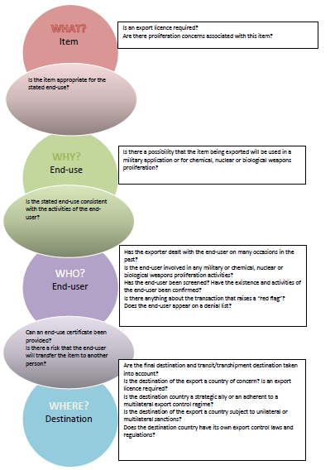

1. Note: *The ICP Guide relies on the term “Commodity Classification Number (CCN) and Export Classification Number (ECN)” throughout. Commodity Control Number (CCN), Export Control Number (ECN) or Export Control Classification Number (ECCN). Your enterprise should determine the appropriate and recognized term utilized in your country. Some countries use the term.*